Software Requirement Specification

**Document History**

|  |  |  |  |  |  |  |
| --- | --- | --- | --- | --- | --- | --- |
| **Document Name** | **Version** | **Status** | **Date** | **Viewable** | **Reviewer** | **Responsible** |
| iWish - SRS V.[1.0].docx | **Add**   * Introduction * URSA * URSW * SRSA * SRSW * Use Case Diagram * Use Case Description | Draft | 20-05-2015 | VC, SK, KS | VC, SK | VC, SK |
| iWish - SRS V.[1.0].docx | **Edit**   * Introduction * URSA * URSW * SRSA * SRSW * Use Case Diagram(Web) * Use Case Description (Web) * Use Case Diagram(Android) * Use Case Description (Android) | Release | 22-07-2015 | VC, SK, KS | VC, SK | VC, SK |
| iWish - SRS V.[1.5].docx | **Edit**   * Introduction * URSA * URSW * SRSA * SRSW * Use Case Diagram(Web) * Use Case Description (Web) * Use Case Diagram(Android) * Use Case Description (Android) | Release | 23-08-2015 | VC, SK, KS | VC, SK | VC, SK |
| iWish - SRS V.[2.0].docx | **Add**   * URSA * URSW * SRSA * SRSW * Use Case Diagram(Web) * Use Case Diagram(Android) * Use Case Description (Android) | Draft | 02-10-2015 | VC, SK, KS | VC, SK | VC, SK |
| iWish - SRS V.[2.0].docx | **Edit**   * Description (Android) | Release | 21-10-2015 | VC, SK, KS | VC, SK | VC, SK |
| iWish - SRS V.[2.5].docx | **Edit**   * SRSA * SRSW * Use Case Diagram(Web) * Use Case Description (Web) * Use Case Diagram(Android) * Use Case Description (Android) | Release | 30-10-2015 | VC, SK, KS | VC, SK | VC, SK |
| iWish - SRS V.[3.0].docx | **Edit**   * SRSA * SRSW * Use Case Diagram(Web) * Use Case Description (Web) * Use Case Diagram(Android) * Use Case Description (Android) | Release | 03-12-2015 | VC, SK, KS | VC, SK | VC, SK |

**\*VC = Visava Chumnuam**

**\*SK = Saksorn Khongsirirat**

**\*KS = Kittitouch Suteeca**

**Table of Contents**

1. Introduction 6

1.1 Project Overview 6

1.1.1 Purpose 6

1.1.2 Scope 6

1.1.3 Acronyms …………………………………………………………………………………………....6

1.1.4 User Characteristic…………………………………………………………………………………...6

2. User Requirements Specification 7

3. System Requirements Specification. 7

4. Use Case Diagram Web 11

4.1 Use Case Description Web 12

5. Use Case Diagram Android 23

5.1 Use Case Description Android 24

# **Introduction**

**1.1 Purpose**

The purpose of software specification is gathering the requirements of the iWish’s software. The document will contain about what are the software should be.

**1.2 Scope**

The application will be developed by Android Studio.

- Focus on only one supermarket.

- Provide system management products in the database.

- Provide the Android application for manage wish list.

- Convenient features for Android application site.

* 1. **Acronyms**

**Acronyms**

ADA Activity Diagram Android

ADW Activity Diagram Web Application

APK Android Package Kit

SDA Sequence Diagram Android

SDW Sequence Diagram Web Application

SK Saksorn Khongsirirat

SRS System Requirement Specification

UCA Use case Diagram Android

UCW Use case Diagram Website

URSA User Requirement Specification Android

URSW User Requirement Specification Website

VC Visava Chumnuam

* 1. **User Characteristic**
     1. **Admin =** the staff of a supermarket which can manage the products in the database and provide information about each product and NFC tag on the shelves.
     2. **Customer** = the people that are a customer of the supermarket and use iWish application.

1. **User Requirements**

* **URSW-01**: Admin can login to the web application.
* **URSW-02**: Admin can add a new product to the system (The product contain product picture, product name, product ID, Description, Category, Price, location x, y and promotion).
* **URSW-03**: Admin can view all products in the system.
* **URSW-04**: Admin can search product by product’s ID in the system.
* **URSW-05**: Admin can edit product’s information.
* **URSW-06**: Admin can delete the product from the system.
* **URSW-07**: Admin can log out from the web application.
* **URSA-08**: The customer can view the shopping cart that show a detail of the product that add by the customer in list format.
* **URSA-09**: The customer can add the new product to the shopping cart by three ways. (Inputting ID of the product manually, using scanning barcode and using scanning NFC).
* **URSA-10**: The customer can edit the amount of product.
* **URSA-11**: The customer can delete the product.
* **URSA-12**: The customer can view the wish list page that show the detail (checkbox, name, amount, total price) of product that add by the customer in list format.
* **URSA-13**: The customer can add a new product to the wish list by selecting from the product list.
* **URSA-14**: The customer can view the detail (name, net weight, price, and promotion) of each product by click on the product.
* **URSA-15**: The customer can view the compare page for comparing two products.
* **URSA-16:** The customer can add a product on the compare page to the wish list by selecting from the product list.

1. **Software Requirements Specification**

* **SRSW-01**: System shall provide login interface to receive ID and password in the center of the login page.
* **SRSW-02**: System shall validate input in a login form for checking all forms are fill or not.
* **SRSW-03**: System shall provide all products interface on the main page to allow admin to see all products in the system.
* **SRSW-04**: System shall show a message “ID and password are incorrect”, in the login form if the user input ID, password or both is wrong.
* **SRSW-05**: System shall provide menu bar on the top of the main page to allow admin to change the interface between “add product” and “all products."
* **SRSW-06**: System shall provide add product interface to receive ID, name, description, category, net weight and price in the add product page.
* **SRSW-07**: System shall verify product’s ID with existing product in the database.
* **SRSW-08**: System shall record product’s information including name, description, category, net weight, price, an amount required for promotion and promotion price in the database.
* **SRSW-09**: System shall show a message “Add Success” on the bottom of the menu bar when the adding process is finish.
* **SRSW-10**: System shall provide a search interface to receive product’s ID on the top of the main page.
* **SRSW-11**: System shall retrieve and show products with similar or same as search input form on the main page’s product list.
* **SRSW-12**: System shall provide edit button for each product for editing the product’s information including name, description, category, net weight, price, an amount required for promotion and promotion price.
* **SRSW-13**: System shall provide edit product interface on the edit page with product’s information in a form to receive new product’s information including name, description, category, net weight, price, an amount required for promotion and promotion price or add amount need for promotion and promotion price except ID.
* **SRSW-14**: System shall update product’s information including name, description, category, net weight, price, an amount required for promotion and promotion price in the database.
* **SRSW-15**: System shall show a message “Edit Success” on the bottom of the menu bar when the editing process is finish.
* **SRSW-16**: System shall provide delete button on the back of each product for delete product’s information.
* **SRSW-17**: System shall ask the admin for confirming to delete the product by providing a confirm dialog on the main page.
* **SRSW-18**: System shall delete the product from the database after the deleting process is complete.
* **SRSW-19**: System shall show a message “Delete Success” on the bottom of the menu bar after the deleting process is complete.
* **SRSW-20**: System shall provide a logout button on the left menu for logging out from the web application.
* **SRSW-21**: System shall query and sent product’s information including id, name, description, category, net weight, price, an amount required for promotion and promotion price in the database to the client by product’ id.
* **SRSW-22**: System shall query and sent all product’s information including id, name, description, category, net weight, price, an amount required for promotion and promotion price in the database to the client.
* **SRSW-23**: System shall query and sent the all category in the database to the client
* **SRSW-24**: System shall query and sent the all product in the database to the client by product’ category.
* **SRSW-25:** System shalllet the admin can edit the product picture.
* **SRSW-26:** System shalllet the admin can delete the product picture.
* **SRSA-27**: System shall display a list that contain the name, the amount of product from the local storage and total price on the shopping cart page and wish list page.
* **SRSA-28**: System shall provide ADD button on the bottom for let the customer add the product.
* **SRSA-29**: System shall ask method (by inputting a product id, scanning a product barcode and scanning product NFC) to add a product to shopping cart.
* **SRSA-30**: System shall add a product to the local storage by inputting a product ID.
* **SRSA-31**: System shall add a product the local storage by scanning a barcode of the product.
* **SRSA-32**: System shall add a product the local storage by scanning NFC of the product.
* **SRSA-33**: System shall provide a text box on the rear of each product for editing amount of product.
* **SRSA-34**: System shall provide Delete button on the back of each product for deleting each product in the list.
* **SRSA-35**: System shall display the wish list page that contain a checkbox for each product, name, amount of each product and total price.
* **SRSA-36**: System shall calculate the total price by calculating price and promotion with an amount of product in the list after some product in the list changed.
* **SRSA-37**: System shall verify products in wish list with products in the shopping cart when the customer access to the wish list page.
* **SRSA-38**: System shall display products in the system by displaying all and displaying by categories for adding to the wish list.
* **SRSA-39**: System shall provide a dialog that contain an ID, name, description, category, net weight, price, an amount required for promotion and promotion of the product when the user click on the product.
* **SRSA-40**: System shall read NFC tag that contain a product ID.
* **SRSA-41**: The system shall provide the compare page to the customer to display two product detail for comparing.
* **SRSA-42**: System shall provide an add button for displaying product by categories to let the customer add two products to compare.
* **SRSA-43**: System shall sort the shortest distance of product to the first product on the wish list page.
* **SRSA-44**: If the customer do not enable NFC. System shall display dialog message “Enable the NFC to using the scanning NFC feature” whenever the customer launch the application.
* **SRSA-45**: System shall provide an OK button for closing dialog message.

1. **Use Case Diagram (Web Application)**

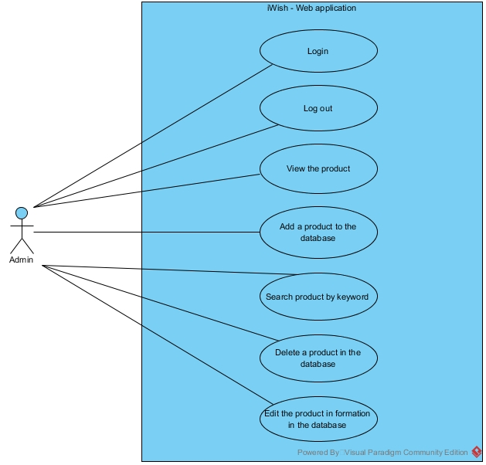

**Figure 7: Use Case Diagram Web Application**

**Use Case Description (Web Application)**

|  |  |
| --- | --- |
| Use Case ID: | UCW-01 |
| Use Case Name : | Login. |
| Short Description : | The admin can login to the web application to use other feature of a web application. |
| Actor: | Admin. |
| Pre-Conditions: | The supermarket must provide ID and password. |
| Post-Conditions: | The admin is login into the system. |
| Trigger | The admin clicks on login button. |
| Flow Of Events: | 1. The admin enters the web application. 2. The system shall direct “Login” page. 3. The admin input ID and password into a text box, then click on “Login” button. 4. The system shall validate ID and password from the database. 5. The system shall redirect to the main page. |
| Alternative Flow: | From 4., If ID and password are invalid,  5a. The system shall show a message “ID and password are incorrect” on the screen. |
| Exception: | - |
| Priority: | High |

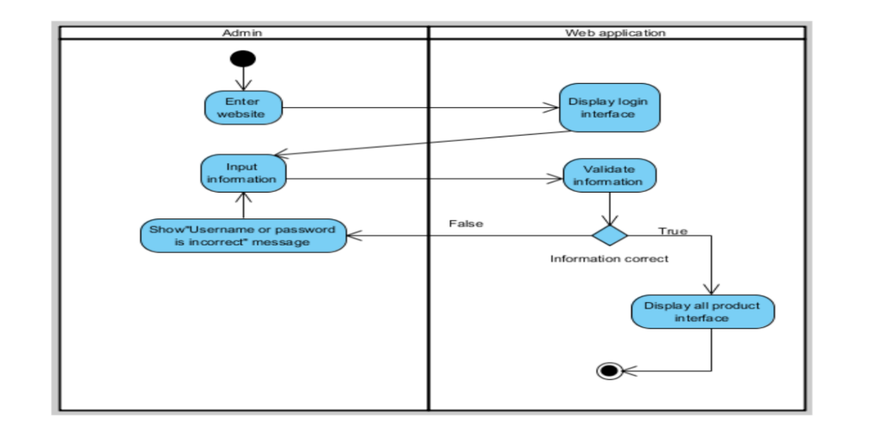

**Figure 8: ADW-01 Login**

|  |  |
| --- | --- |
| Use Case ID: | UCW-02 |
| Use Case Name : | Add new a product to the database. |
| Short Description : | Admin can add a new a product that doesn’t exist in the system. |
| Actor: | Admin. |
| Pre-Conditions: | Login. |
| Post-Conditions: | The admin can see a new product in the product list. |
| Trigger: | The customer clicks on “Add” button on a left menu bar. |
| Flow Of Events: | 1. The admin select “Add Product” on a left menu bar. 2. The system shall redirect to “add product” page. 3. The admin input all information of the product into each text box except promotion part, then select “Add”. 4. The system shall verify product by ID. 5. The system shall create the product in the database. 6. The system shall redirect to the main page. 7. The system shall show a message “Add Success” at the bottom of menu bar |
| Alternative Flow: | From 4., If the product already exists in the system,  5a. The system shall redirect to the main page. |
| Exception: | - |
| Priority: | High |

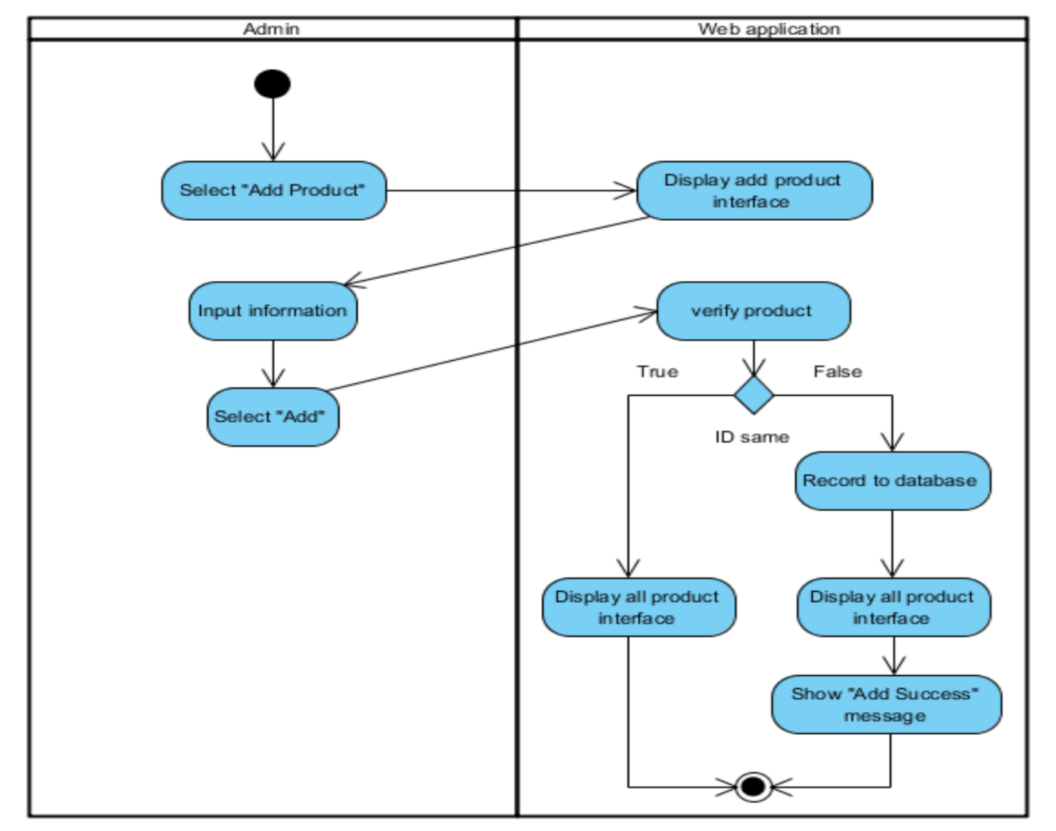

**Figure 9: ADW-02 Add New Product**

|  |  |
| --- | --- |
| Use Case ID: | UCW-03 |
| Use Case Name : | View products. |
| Short Description : | The admin can see all products including product name and detail in the database on the main page. |
| Actor: | Admin. |
| Pre-Conditions: | Login. |
| Post-Conditions: | The admin can see the list of product. |
| Trigger: | The admin clicks on the "All Product" button. |
| Flow Of Events: | 1. The Admin click "All Product" button from a menu bar. 2. The system shall redirect to the main page. |
| Alternative Flow: | - |
| Exception: | - |
| Priority: | Medium |

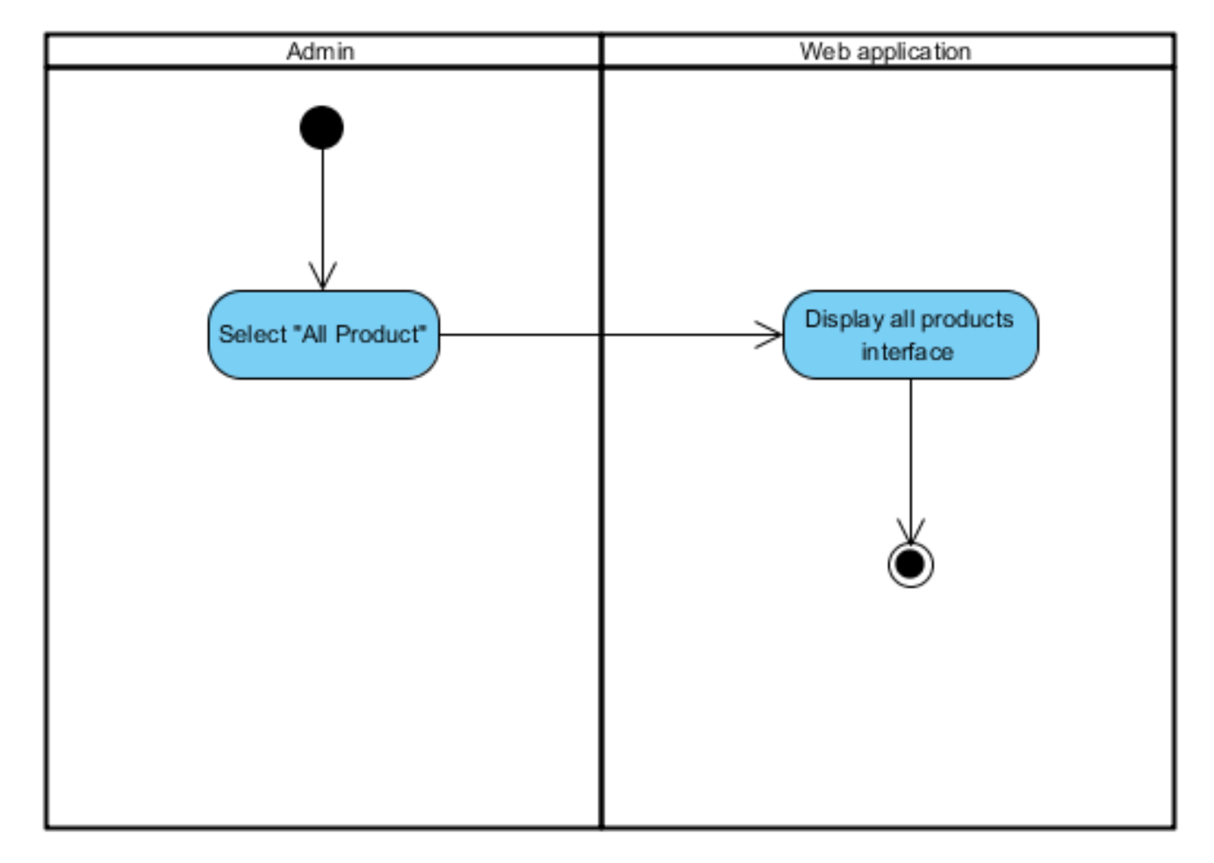

**Figure 10: ADW-03 View Product**

|  |  |
| --- | --- |
| Use Case ID: | UCW-04 |
| Use Case Name : | Search product by keyword. |
| Short Description : | Admin can search for products that already exist in the system by input the keyword of the product in the search box. |
| Actor: | Admin. |
| Pre-Conditions: | Access to the main page. |
| Post-Conditions: | The admin can see the products that relate with the keyword on the list of the main page. |
| Trigger: | The admin input some alphabet or number in the search box |
| Flow Of Events: | 1. The admin input product’s keyword into a search box. 2. The system shall show products with same or similar to product’s id that admin inputted. |
| Alternative Flow: | - |
| Exception: | - |
| Priority: | Medium |

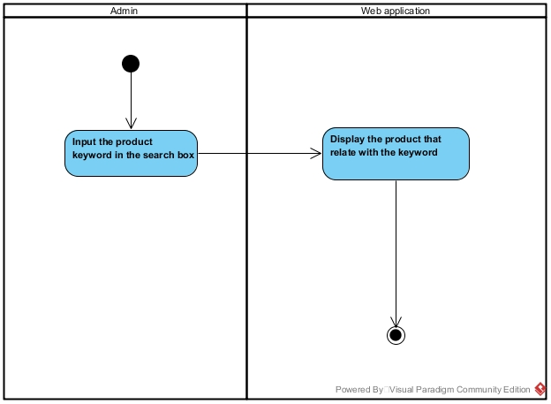

**Figure 11: ADW-04 Search Product by keyword**

|  |  |
| --- | --- |
| Use Case ID: | UCW-05 |
| Use Case Name : | Edit product information in the database. |
| Short Description : | The admin can edit the information of the product that in the database. |
| Actor: | Admin. |
| Pre-Conditions: | Access to the main page. |
| Post-Conditions: | The admin can see the new product information. |
| Trigger: | The admin clicks on the edit button on the back of the product. |
| Flow Of Events: | 1. The admin click edit in a row of product that admin want to edit. 2. The system shall retrieve the information of the product and redirect to edit page. 3. The admin edit information that in a text box of each information. Also, edit and delete the picture of the product and then select edit. 4. The system shall update the information of the product in the database. 5. The system shall redirect to the main page. 6. The system shall show a message “Edit Success” on the bottom of the menu bar. |
| Alternative Flow: | - |
| Exception: | The admin has to delete the picture of the product before adding a new picture. |
| Priority: | High |

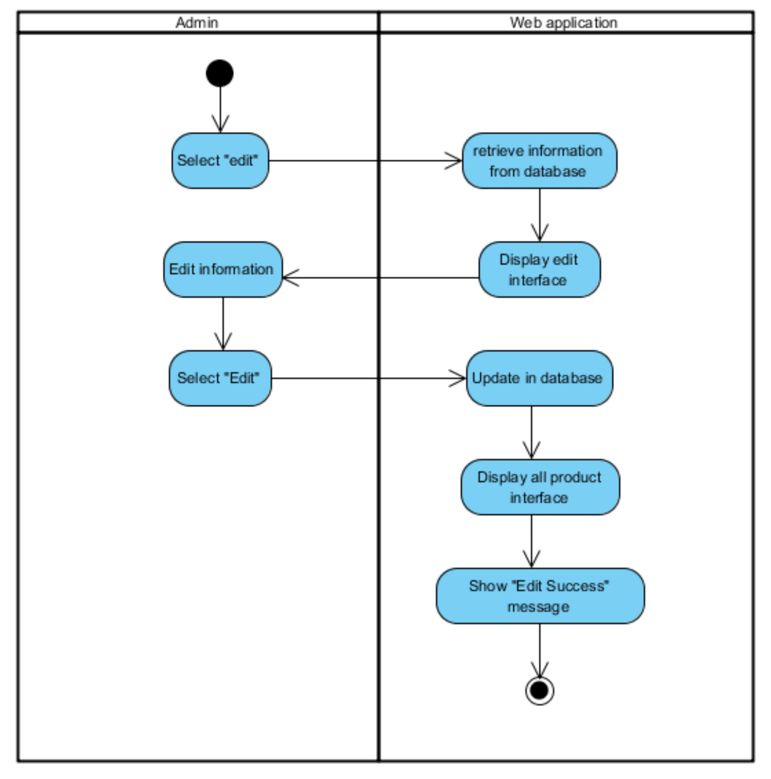

**Figure 12: ADW-05 Edit Product’s Information**

|  |  |
| --- | --- |
| Use Case ID: | UCW-06 |
| Use Case Name : | Delete product from the database. |
| Short Description : | The admin can delete the product that already exists in the database and doesn’t sell anymore to prevent too much record in the database. |
| Actor: | Admin. |
| Pre-Conditions: | Access to the main page |
| Post-Conditions: | The admin can see the product disappears from the list |
| Trigger: | The admin clicks on delete button on the back of the product. |
| Flow Of Events: | 1. The admin select delete in a row of product that admin wants to delete. 2. The system shall ask for confirming by display the confirmation dialog. 3. The admin select “OK” on the confirmation dialog. 4. The system shall delete the product from the database. 5. The system shall show a message “Delete Success” on the bottom of the menu bar. |
| Alternative Flow: | From 2., If the admin selects “cancel”,  3a. Nothing happen. |
| Exception: | - |
| Priority: | Medium |

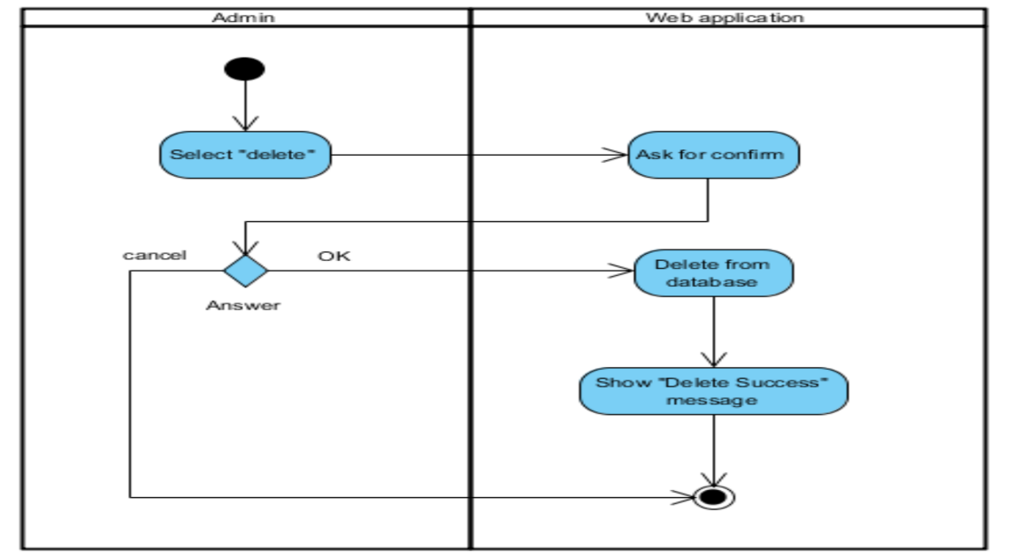

**Figure 13: ADW-06 Delete Product**

|  |  |
| --- | --- |
| Use Case ID: | UCW-07 |
| Use Case Name : | Log out. |
| Short Description : | The admin can log out from the web application for security. |
| Actor: | Admin. |
| Pre-Conditions: | Login. |
| Post-Conditions: | The admin is logged out. |
| Trigger: | The admin clicks on the "logout" button. |
| Flow Of Events: | 1. The admin select "log out" button on the left menu. 2. The system redirects to “log in” page. |
| Alternative Flow: | - |
| Exception: | - |
| Priority: | Low |

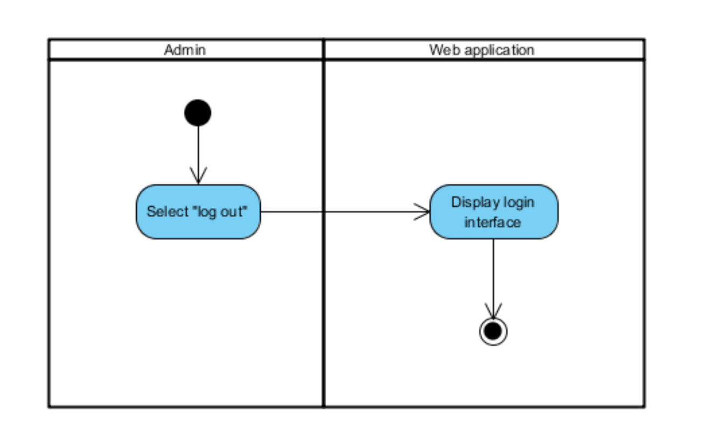

**Figure 14: ADW-07 Log out**

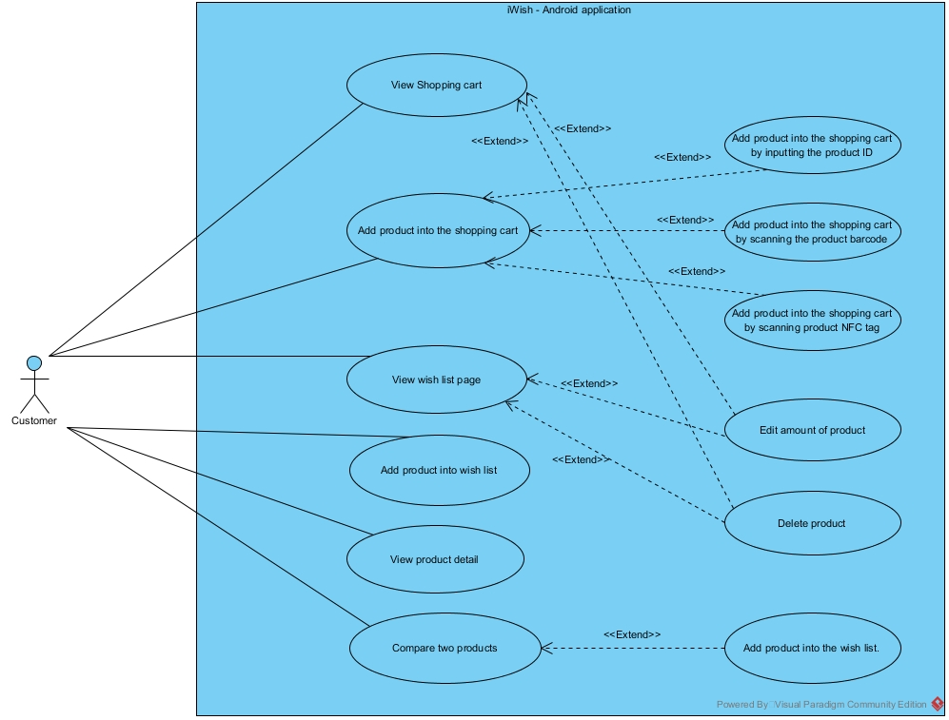

**Figure 15: Use Case Diagram Android Application**

|  |  |
| --- | --- |
| Use Case ID: | UCA-01 |
| Use Case Name : | View shopping cart |
| Short Description : | The customer can see the list of product on the shopping cart page. |
| Actor: | Customer. |
| Pre-Conditions: | Launch the application |
| Post-Conditions: | The customer can see the product list of the shopping cart. |
| Trigger: | The customer clicks on the "Shopping Cart" button from a menu bar. |
| Flow Of Events: | 1. The customer select "Shopping Cart" button from a menu bar. 2. The system receives the product list from the local storage. 3. The system calculates the total price of all product. 4. The system displays shopping cart to the customer. |
| Alternative Flow: | - |
| Exception: | - |
| Priority: | Medium |

## D:\View Shop.jpg

**Figure 16: ADA-01 View Shopping Cart**

|  |  |
| --- | --- |
| Use Case ID: | UCA-02 |
| Use Case Name : | Add product to shopping cart. |
| Short Description : | The customer can add a product to the shopping cart by three ways for doing next process. |
| Actor: | Customer. |
| Pre-Conditions: | The admin provides the product detail in the database. |
| Post-Conditions: | The customer can see the new product shows on the shopping cart list. |
| Trigger: | The customer clicks on the Add button at the bottom of the shopping cart page. |
| Flow Of Events: | 1. The customer select "Shopping Cart" from the menu bar. 2. The customer selects Add button at the bottom of the shopping cart page. 3. The system displays the add dialog on the screen. 4. The customer select "Input ID". 5. The system displays the input form on the screen. 6. The customer input the product id into the form. 7. The system connects to the web application and receives the product details. 8. The system sorts the shortest distance of the products in the wish list. 9. The system saves the product to the local storage. 10. The system reloads the page with the new product. |
| Alternative Flow: | From 3rd flow, customer can select "Barcode" for adding a product to the cart by scanning barcode  4. The system open camera feature.  5. The customer takes a picture on product barcode.  6. The system connects to the web application and receives the product details.  7. The system sorts the shortest distance of the products in the wish list.  8. The system saves the product into the local storage.  9. The system reloads the page with the new product.  From 3rd flow, the customer can select "NFC" for adding a product to the cart by scanning NFC tag.  4. The customer brings the smartphone near on product NFC tag.  5. The system connects to the web application and receives the product details.  6. The system sorts the shortest distance of the products in the wish list.  7. The system saves the product to the local storage.  8. The system reloads the page with the new product. |
| Exception: | - |
| Priority: | Medium |

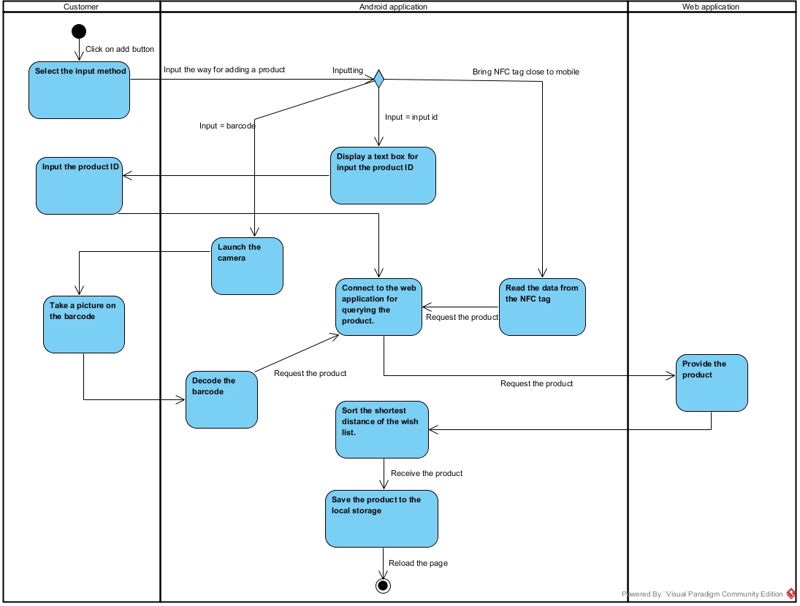

**Figure 17: ADA-02 Add Product in Shopping Cart**

|  |  |
| --- | --- |
| Use Case ID: | UCA-03 |
| Use Case Name : | Edit amount of product. |
| Short Description : | The customer can edit the amount of product in the shopping cart or the wish list. |
| Actor: | Customer. |
| Pre-Conditions: | **For Editing in the Shopping Cart:**  Access to the Shopping Cart.  **For Editing in the Wish List:**  Access to the Wish List. |
| Post-Conditions: | The customer can see the page with the new amount of product. |
| Trigger: | The customer clicks on the amount of the product. |
| Flow Of Events: | 1. The customer clicks on the amount of the product. 2. The system pop up a virtual numerical keyboard on the screen. 3. The customer input amount of product. 4. The system reloads the page with a new amount of product. |
| Alternative Flow: | - |
| Exception: | - |
| Priority: | Medium |

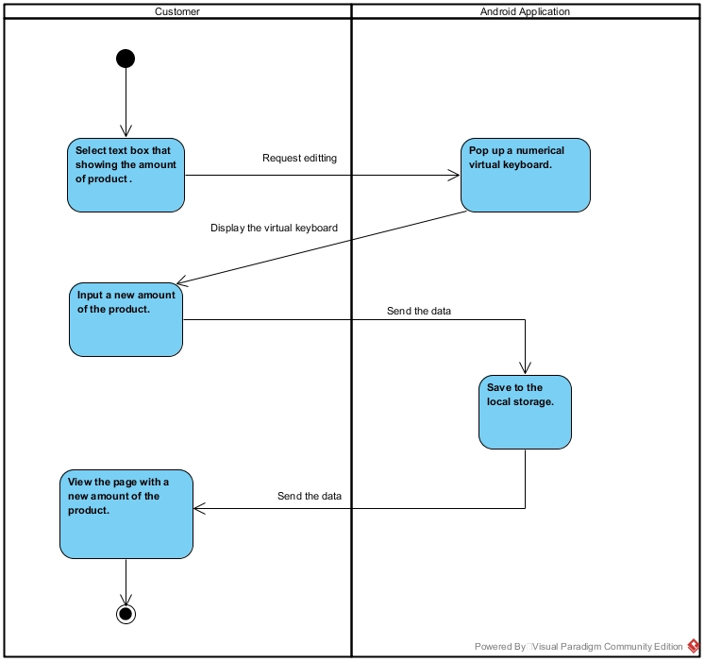

**Figure 18: AD-03 Edit Amount of Product**

|  |  |
| --- | --- |
| Use Case ID: | UCA-04 |
| Use Case Name : | Delete the product. |
| Short Description : | The customer can delete the product from the shopping cart or the wish list. |
| Actor: | Customer. |
| Pre-Conditions: | **For Deleting in the Shopping Cart:**  Access to the Shopping Cart.  **For Deleting in the Wish List:**  Access to the Wish List. |
| Post-Conditions: | The customer cannot see the product that they delete in the list. |
| Trigger: | The customer clicks on the delete button of the product. |
| Flow Of Events: | 1. The customer clicks on delete button on the back of the product name. 2. The system is asking confirmation to the customer by displaying a confirmation dialog. 3. The customer select "Yes" button. 4. The system deletes the product from the local storage. 5. The system reloads the page without showing the product that the customer delete in the list. |
| Alternative Flow: | From 4th flow, If the customer selects "No" button.  4. The customer select "No" button.  5. The system reloads the page with the product that the customer cancel to delete in the product list. |
| Exception: | - |
| Priority: | Medium |

## D:\Delete.jpg

**Figure 19: ADA-04 Delete Product**

|  |  |
| --- | --- |
| Use Case ID: | UCA-05 |
| Use Case Name : | View wish list |
| Short Description : | The customer can see the list of product that added to the wish list by the customer on the wish list page. |
| Actor: | Customer. |
| Pre-Conditions: | Launch the application |
| Post-Conditions: | The customer can see the list of product on the wish list page. |
| Trigger: | The customer select “Wish list” from the menu bar. |
| Flow Of Events: | 1. The customer select "Wish list" from the menu bar. 2. The system load the save file in the local storage that contain the list of product. 3. The system calculates the total price of all product. 4. The system checks the products that already in the shopping cart. 5. The system highlights the check box of the product that already in the shopping cart. 6. The system sort the shortest product distance. Bring the product on the first on the wish list. 7. The system displays the wish list page with the data to the customer. |
| Alternative Flow: | From the 3rd flow. If there are no the same product, the system will display the wish list page to the customer. |
| Exception: | - |
| Priority: | Medium |

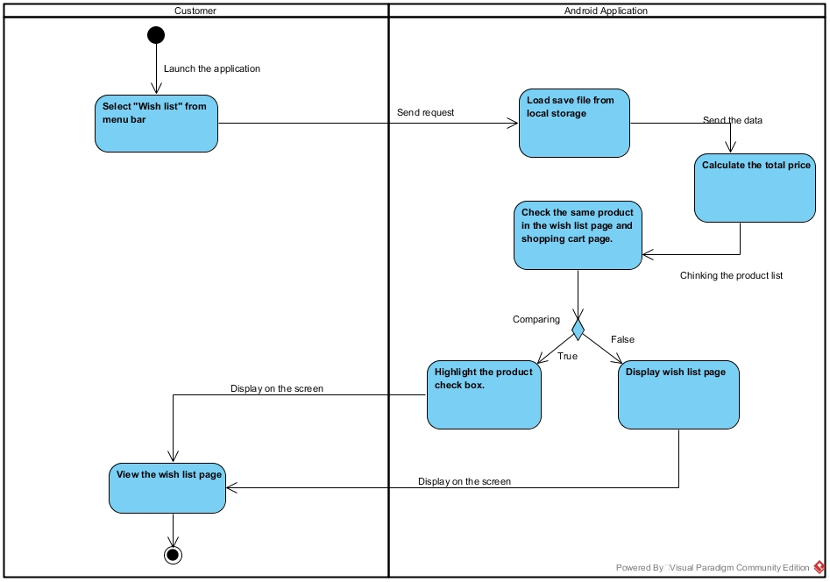

**Figure 20: ADA-05 View wish list.**

|  |  |
| --- | --- |
| Use Case ID: | UCA-06 |
| Use Case Name : | Add a product to the wish list. |
| Short Description : | The customer can add a product to the wish list of application for doing next process by selecting the product list that query from the database. |
| Actor: | Customer. |
| Pre-Conditions: | The admin must provide the product in the database. |
| Post-Conditions: | The customer can see the new product on the wish list page. |
| Trigger: | The customer selects "+" button on the lower of the page. |
| Flow Of Events: | 1. The customer select the “Wish list “from the menu bar. 2. The customer selects "+" button on the lower of the page. 3. The system query the product categories. 4. The customer selects the product category. 5. The system queries the products from the web application that are the same selected category. 6. The customer select the product that they would like to add. 7. The system saves the product into the local storage. 8. The customer hold-clicks on the product name. |
| Alternative Flow: | - |
| Exception: | - |
| Priority: | Medium |

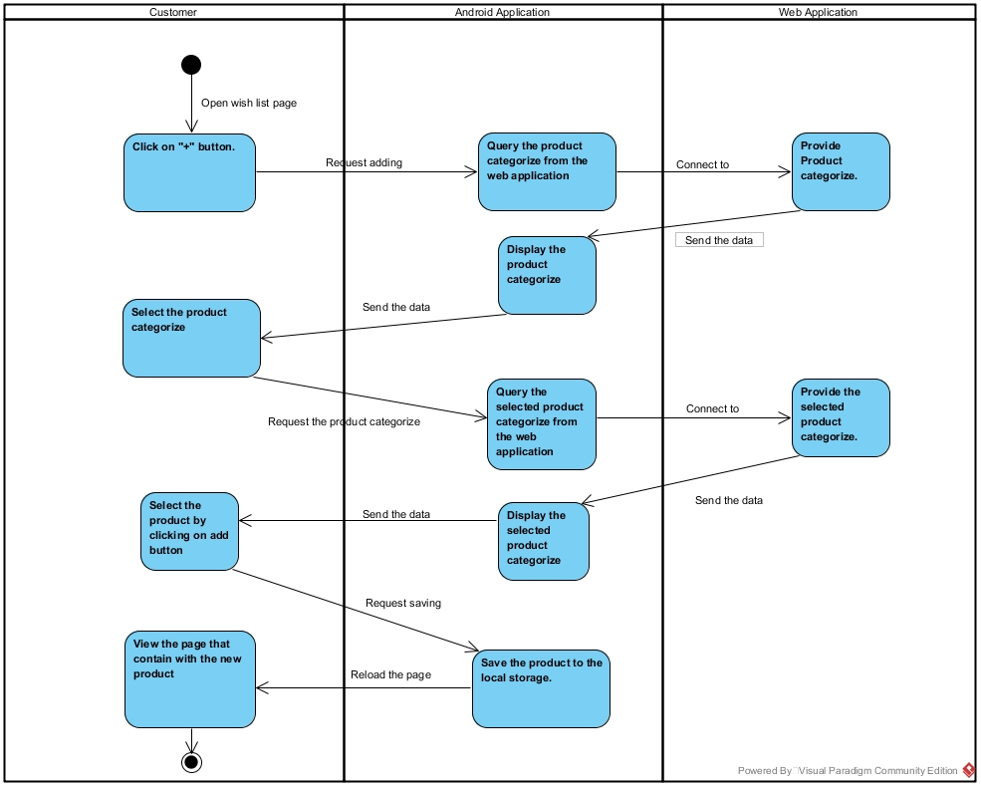

**Figure 21: ADA-06 Add product to the wish list.**

|  |  |
| --- | --- |
| Use Case ID: | UCA-07 |
| Use Case Name : | Check product detail. |
| Short Description : | The customer can view a product detail that contain the ID, name, description, category, net weight, price, the amount required for promotion and promotion of the product when the user click on the name of the product. |
| Actor: | Customer. |
| Pre-Conditions: | The customer access to wish list page. |
| Post-Conditions: | The customer can see the dialog that contain the product detail. |
| Trigger: | The customer hold-clicks on the product name. |
| Flow Of Events: | 1. The customer hold-clicks on the product name. 2. The system shows a dialog that contain the detail of that product. |
| Alternative Flow: | - |
| Exception: | - |
| Priority: | Medium |

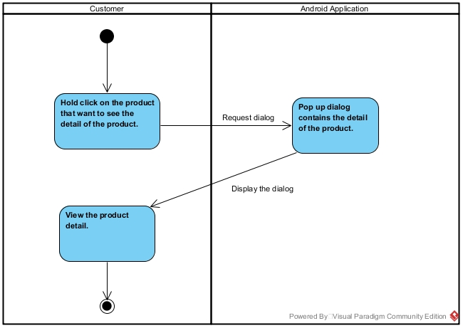

**Figure 22: ADA-07 Check product detail.**

|  |  |
| --- | --- |
| Use Case ID: | UCA-08 |
| Use Case Name : | Compare two products. |
| Short Description : | The customer can compare two products for making a decision on the compare page by selecting two product from the product list. The application will display both of product detail and a “+” button for adding the product to the wish list. |
| Actor: | Customer. |
| Pre-Conditions: | The customer access to compare page. |
| Post-Conditions: | The customer can see the product detail of two selected products. |
| Trigger: | The customer adds two products to the compare page. |
| Flow Of Events: | 1. The custom clicks on compare button on the lower of the page. 2. The system connects to the web application and receives the product categories. 3. The customer select the product category. 4. The system receives and displays all product with the same category. 5. The customer select two products by click on the checkbox at the front of the product name. 6. The system shows product detail of two selected product. |
| Alternative Flow: | -To adding the products to the compare page to the wish list.   1. The custom clicks on the + button below the product that they want to add. 2. The system saves the product to the wish list. |
| Exception: | - |
| Priority: | Low |

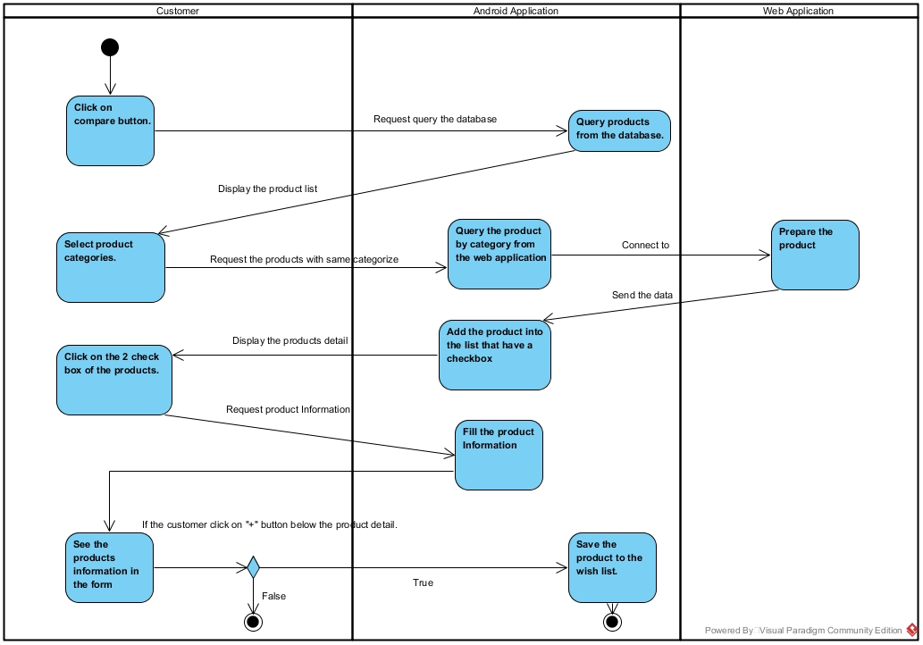

**Figure 23: ADA-08 Compare two products.**